World Views
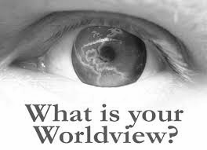

Atheism: a view that does not believe in the existence of God or Gods.

Agnosticism: a belief that people can not know for certain whether God exists or not.

Materialism: is a view that only material things are real. It is a way of life. People who are materialists believe life is about owning lots of possessions and having lots of money to enjoy yourself.

Fundamentalism: people who are fundamentalists take the Bible literally. They believe that the Bible is a factual book that is full of stories that we should believe are truth.

Humanism: a belief system that rejects organised religion. Humanists do not believe in God their faith is in human beings. They find meaning in life through human experiences and struggles we face.

Monotheism: a belief in one God.

Polytheism: a belief in more than one God.

