The Expression of Faith

Prayer
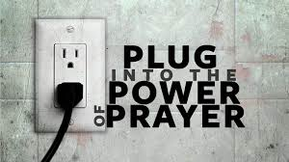
When we pray we express our faith. It is how we talk to God. When we pray we our opening our hearts to let God in. We ask him to keep the people we love safe. We ask him to watch over us. Prayer can be formal and informal. Formal prayer is saying a well known written prayer like the ‘Our Father’. Informal prayer is when we use our words to ‘chat’ with God. Prayer can give us support and comfort in times of trouble.

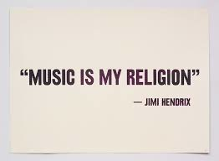
Music
Liam Lawton is an example of someone who believes music can be used as a form of prayer. A lot of people say music is something they love. With new TV talent shows like X Factor people go on TV and get interviewed to tell us how much they love music and how it brought them comfort in hard times. It brings passion and happiness into their lives. It helps people express themselves and express their feelings. Lyrics can speak about the search for meaning.

Worship
People can express their faith by going to Mass to worship God. Worshipping shows respect. It allows people to honour and praise God. The Sacraments are also a form of worship.

