Genesis Story: Past and Present

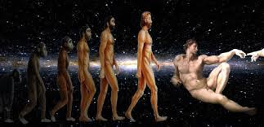
In the past the story of Genesis was read literally. This meant that people read and understood this story to be factual. One word used to describe Christians who read the Bible literally was fundamentalist. People who believed everything that was written in the Bible was truth were called fundamentalists. They believed that God was the creator of the world and that he created the world in 6 days. They also believed that human beings held a very special place in the world because as the Bible says we were made in God’s image or to be like God.

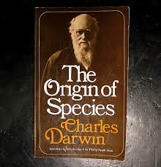
However, today Christians believe something very different. A man called Charles Darwin published a book called ‘The Origins of Species’. This book made a lot of Christians very angry. In this book Darwin seemed to suggest that the world was not created in 6 days but that it has evolved and developed over millions of years. He also suggested that human beings along with all other living creatures have evolved from one another. This was called Darwin’s Theory of Evolution. He was very worried about what the Church would think about his theory because he was a religious man and believed in God. He became scarred that the Church would think he was trying to say that God did not create the world.

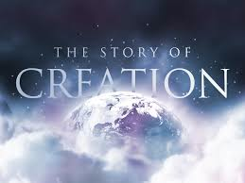
Today however, we understand that the Bible is not a scientific document and was never meant to be read as a scientific book. The Bible is a collection of stories. Some stories like the creation story have a meaning behind them. Christians today also believe in Darwin’s theory of evolution. We have learnt that the story about the creation of the world was written to teach us about the power of God. It teaches us why the world was created and that God created everything in this world out of love. It teaches us about awe and wonder and that we should respect such an amazing creation.

