Compare Islam with Christianity

Keyword: Compare | To compare means to look at what they have in common and the differences between them.

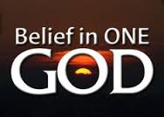

- Christianity and Islam are both monotheistic religions. This means that they both believe in one God (Allah).

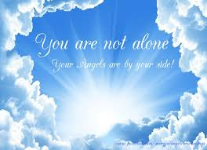

- They both believe in Angels and life after death.

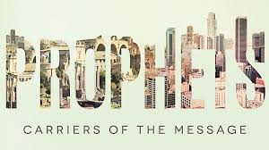
- They have some of the same prophets. A prophet is someone who speaks on behalf of God. They usually receive important messages from God and God tells them to spread his message to the people. In Christianity and Islam the two prophets they share are Abraham and Moses.

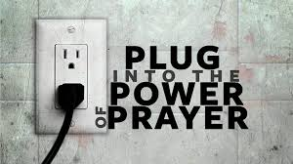
- Both Christianity and Islam believe prayer is extremely important. Muslims pray 5 times a day and Christians pray to God every Sunday at Mass and sometimes before meals and bedtime. Praying is a way for both Christians and Muslims to talk to God or Allah.

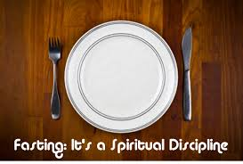
- Fasting is also a common feature they share. Muslims fast during the month of Ramadan, which is one of the 5 pillars of Islam. Christians fast during lent. A person of both religions fast because it helps them appreciate all that God has given them.

- Both Muslims and Christians donate to charity. Giving to charity is a requirement if you are Muslim and have the money to do so. They give a small bit of their salary to charity every month. This is one of the 5 pillars of Islam called Zakat. Christian organizations also do a lot for charity. An example of a Christian charity organisation would be Saint Vincent de Paul.

