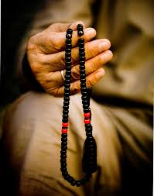
Islam Symbol - Prayer Beads
Prayer beads are also known as Masbaha, Sibha or Tasbeeh
and are an important symbol used in Islam to help with
meditation. Islam prayer beads have 99 individual beads,
each bead represents one of the ninety-nine names of
Allah, the one hundredth name is known to Allah alone.
The beads help the user to count the number of prayers said.

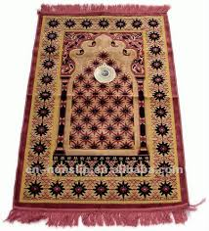
Islam Symbol - Prayer Rug
Prayer rugs are an extremely important Islam symbol and are used by Muslims when they pray to Allah. The word 'salat' is used to describe the ritual prayers that are recited five times a day by those who follow the Islamic faith. Prayer mats are placed on the floor and worshippers kneel on the rug to say their prayers. It is vital that the prayer mats are placed facing Mecca, the holy place for Muslims. Prayers are usually said at dawn, midday, afternoon, sunset and evening. Before praying, the hands feet and face must be washed, a process called ablutions.

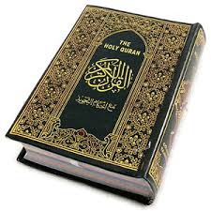
Islam Symbol - Koran
The Koran, also spelt Quran is the sacred book of Islam and the most important symbol of the faith. The Koran is written in Arabic and beautifully inscribed with calligraphy. Muslims believe that the verses of the Koran are proof that Muhammad was a prophet and the words in the Quran are the true word of god. The Koran provides guidance and direction for humanity.

Islam Symbol - Star & Crescent
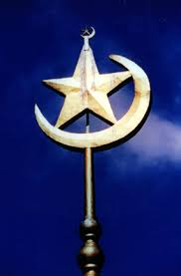
The crescent moon is an extremely important symbol in Islam, it symbolizes concentration and openness. Usually pictured next to a star which symbolizes paradise, as shown in the picture on the right.

