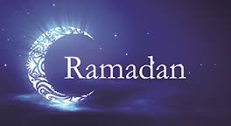
Source: https://www.youtube.com/watch?v=SgkX7ryuuEs Student Name: .

Challenge yourself- Watch and Answer
Watch this video explaining Ramadan, the holiest month in the Islamic Calendar. How much can you learn from this 2 minute clip?
- What do Muslims do during Ramadan?

- Ramadan is a month of P .

- What famous Islam event is believed to have happened during Ramadan?

- Who is exempt (unable) to part take in Ramadan and what do they do instead of fasting?

- What month of the year does happen Ramadan occur?

- How do Muslims decide when Ramadan will happen?

- What happens at sunset?

- How does Ramadan end? Name the Holiday.

