Stages of Faith

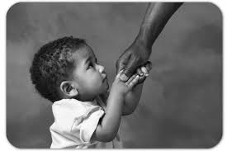
Childhood faith - childhood faith is an imitative faith – children imitate the faith and religious practices of their parents and other important adults. This stage of faith can be described as very trusting. We are influenced by people around us in our family. At this age we don’t really understand our faith but we follow others by practicing it and copying things we see other people doing like kneeling down to pray.

Adolescent (teenage stage) - the teenage faith is the questioning stage. Teenagers ask questions about their religion and explore other religions or world views. We see God as an authority figure, he is someone who watches over us to see if we do good or bad things. At this stage we are not really interested in our faith and sometimes we can turn away from religion. We ask questions like ‘is this what I believe?.

Mature Faith - God is mysterious and loving. People at this stage have thought deeply about their faith and have made the decision to believe and practice for themselves. At this stage people begin to accept God for what he is. They continue to ask questions about the meaning of life. They are comfortable talking about their faith. Their Religion and Faith is very much a part of their lives. Some people don’t move beyond the childhood stage. They don’t ask questions. They remain at the childhood stage or forget about their faith. We can sum up this stage as ‘This is what I believe.’

