The Prophet Muhammad

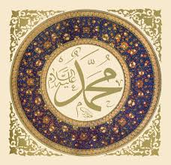

Who was Muhammad?

- Muhammad is the founder of Islam.

- He was born in Mecca in 570 AD.

- He became an orphan at the age of 6 and was raised by his uncle.

- He worked for his uncle as a shepherd.

- He married his wife Khadija when he was 25 years old and they had a very happy marriage.

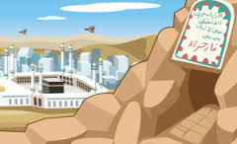
The Night of Power

- In 610 AD Muhammad visited a cave on
Mount Hira where he liked to be
alone to think and find peace.

- Muhammad says that while in the cave
the Angel Gabriel appeared to him
and told him to:

‘Proclaim: Your Lord is the Most Generous,
Who teaches by the pen; Teaches man what he knew not.’ (Qur'an 96:1-3)

- He had been chosen as the messenger of Allah and began to proclaim Allah’s message.

- He rushed back to his wife to tell her this amazing story. She was the first person to believe him and became the first follower of Islam.

- Muhammad began to tell everyone to stop believing in false God’s and only believe in one true God, Allah.

The Night Journey
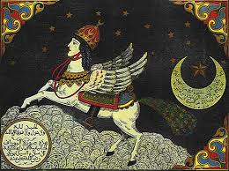
- Muhammad’s wife Khadija died in 619 AD and he became very sad.

- He liked to visit the Ka’ba late at night. He would stand there and pray during the night.

- One night he was very tired and fell asleep and the Angel Gabriel came back to visit Muhammad again.

- He shook Muhammad and woke him up and took him on a journey from Mecca to Jerusalem to visit the farthest Mosque Al-Aqsa on a white beast called Buraq.

“a beast unlike any other, something between a donkey and a mule. It had a face like that of a human and its body was that of a horse. It was a finer beast than any other on earth”

- After visiting Jerusalem Muhammad went up to the heavens, paradise and hell. He met many of the prophets (Abraham, Moses, and Jesus are the most frequently mentioned) and talked to God.

- Here, God told him that Muslims only need to pray 5 times a day.

The hijira

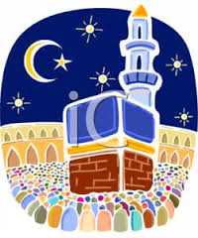
        - Mecca the town where he grew up was full of people who wanted to be rich and people who worshipped false Gods.

        - After his Night Journey to the heavens and Jerusalem Muhammad began to teach people about Islam and prayer.

        - When Muhammad began to teach people about Allah he upset a lot of people and his followers were persecuted. This led to violence against Muhammad’s followers.

- Muhammad however, received good news. He was told that a lot of people were beginning to follow him in a town called Yathrib. This city is now Medina.

- Muhammad fled from Mecca to Yathrib where he was welcomed with open arms. This event is known as the Hijira.

- The year in which it occurred, 622 AD, is the date at which the Muslim calendar begins.

